**High-Level Design**

We are using event-based architecture. Our project is mainly a GUI with lots of buttons, so writing our code in a way that button presses are events that trigger updates when pressed makes logical sense. Any real-time updates that aren’t related to buttons will be in response to the current time, which is essentially just another event.

**Low-Level Design**

The creational design pattern family will be the most helpful in designing this project. Our project revolves heavily around the creation of new tasks with different attributes that then compose the overall application GUI. The creation of these tasks is one of the primary motivations for this project; thus, the creational design pattern family best suits its purpose.

The following code is a simple JavaScript function that is already implemented in our prototype. This function adds a new task element on the click of an “Add” button.

function newElement() {

var li = document.createElement("li");

var inputValue = document.getElementById("myInput").value;

var t = document.createTextNode(inputValue);

li.appendChild(t);

if (inputValue === '') {

alert("You must write something!");

} else {

document.getElementById("myUL").appendChild(li);

}

document.getElementById("myInput").value = "";

var span = document.createElement("SPAN");

var txt = document.createTextNode("\u00D7");

span.className = "close";

span.appendChild(txt);

li.appendChild(span);

for (i = 0; i < close.length; i++) {

close[i].onclick = function() {

var div = this.parentElement;

div.style.display = "none";

}

}

}

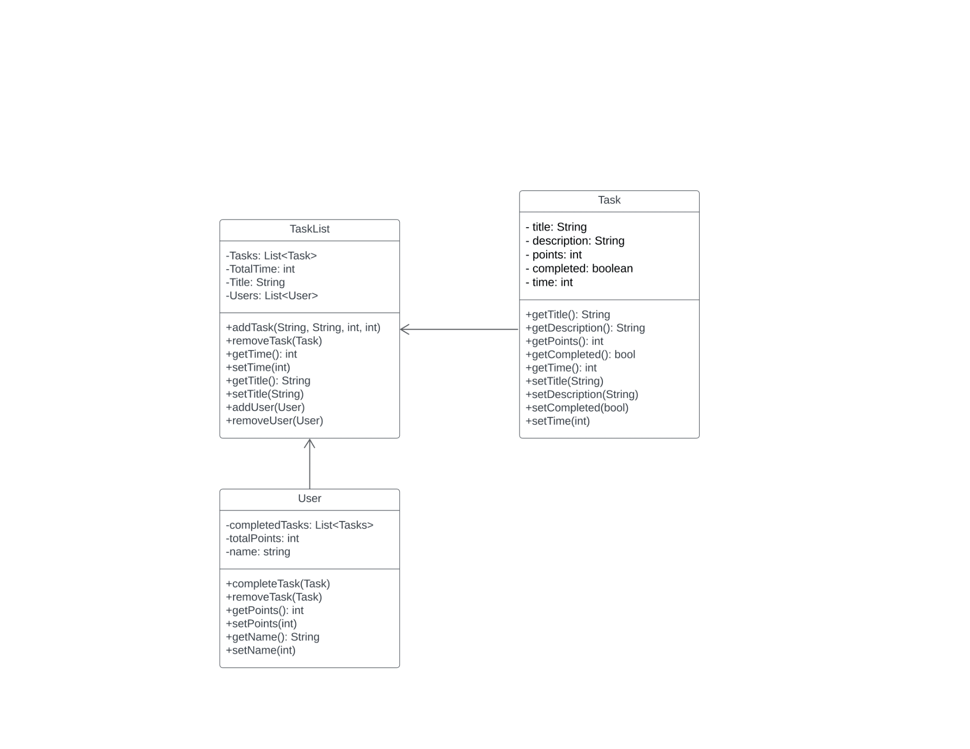

**Design Sketch**

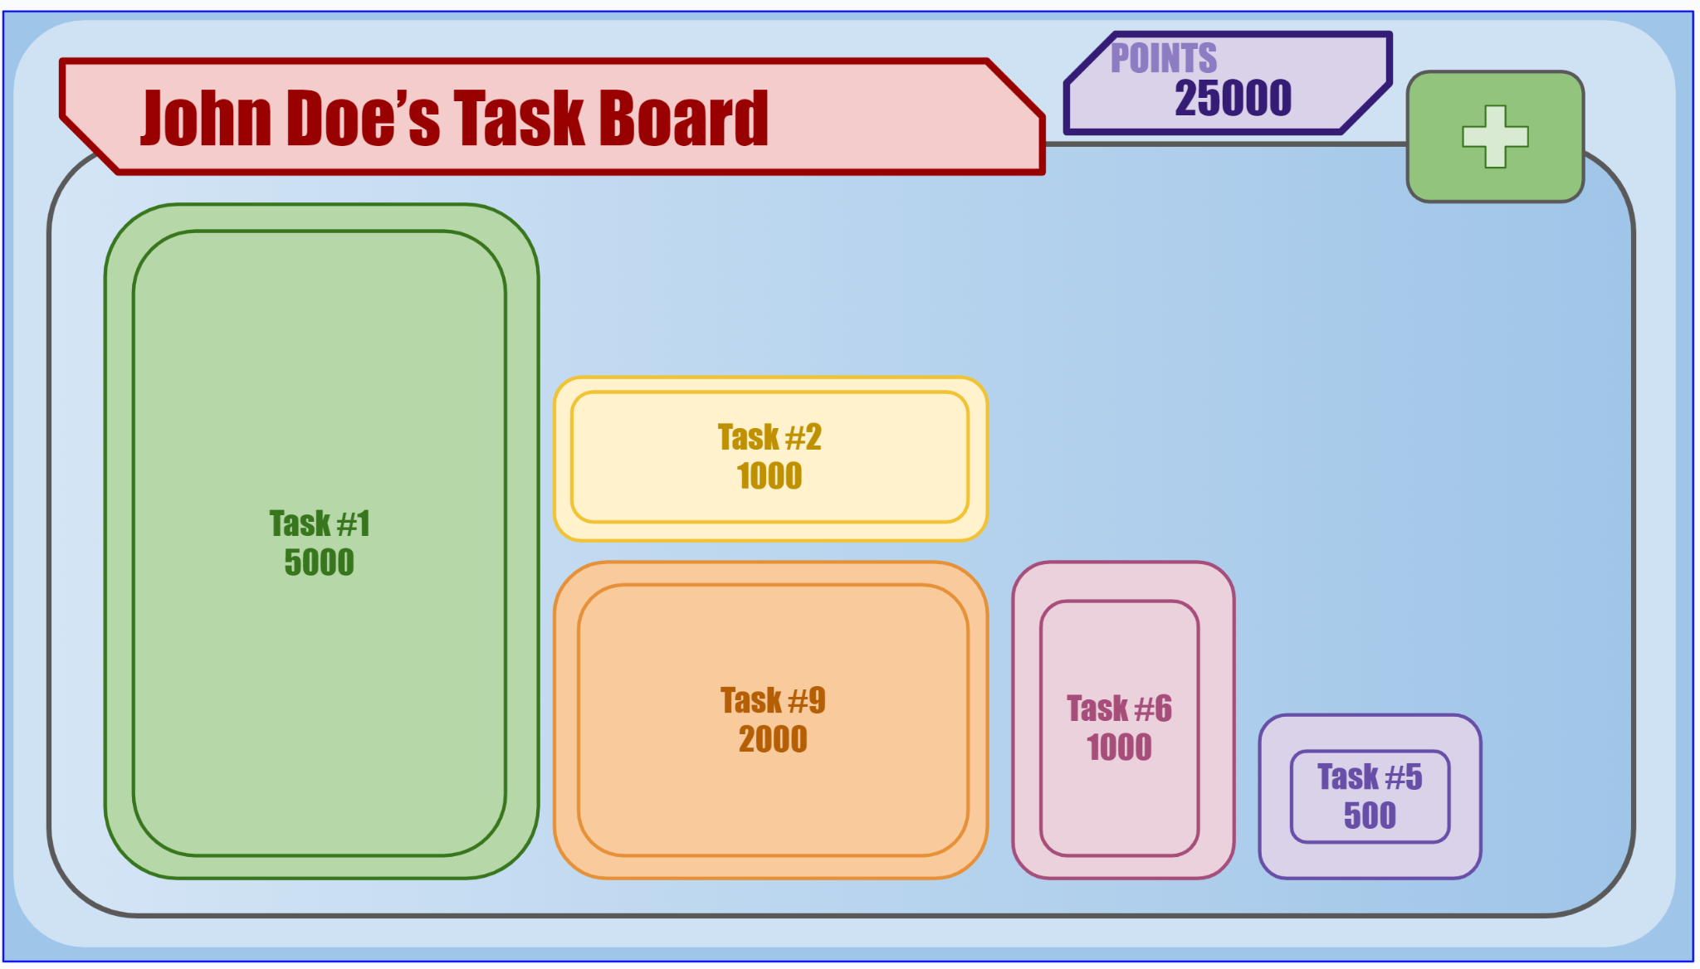

This is the default view of someones’ task board where they have added 9 tasks, and completed some intermittently. Notable features is the simple UI that features important or time consuming tasks as larger tasks. Additionally, the point system is noteworthy as the size correlates with the amount of points scored from completing that respective task. Currently, John Doe has completed enough tasks to have 25000 points.

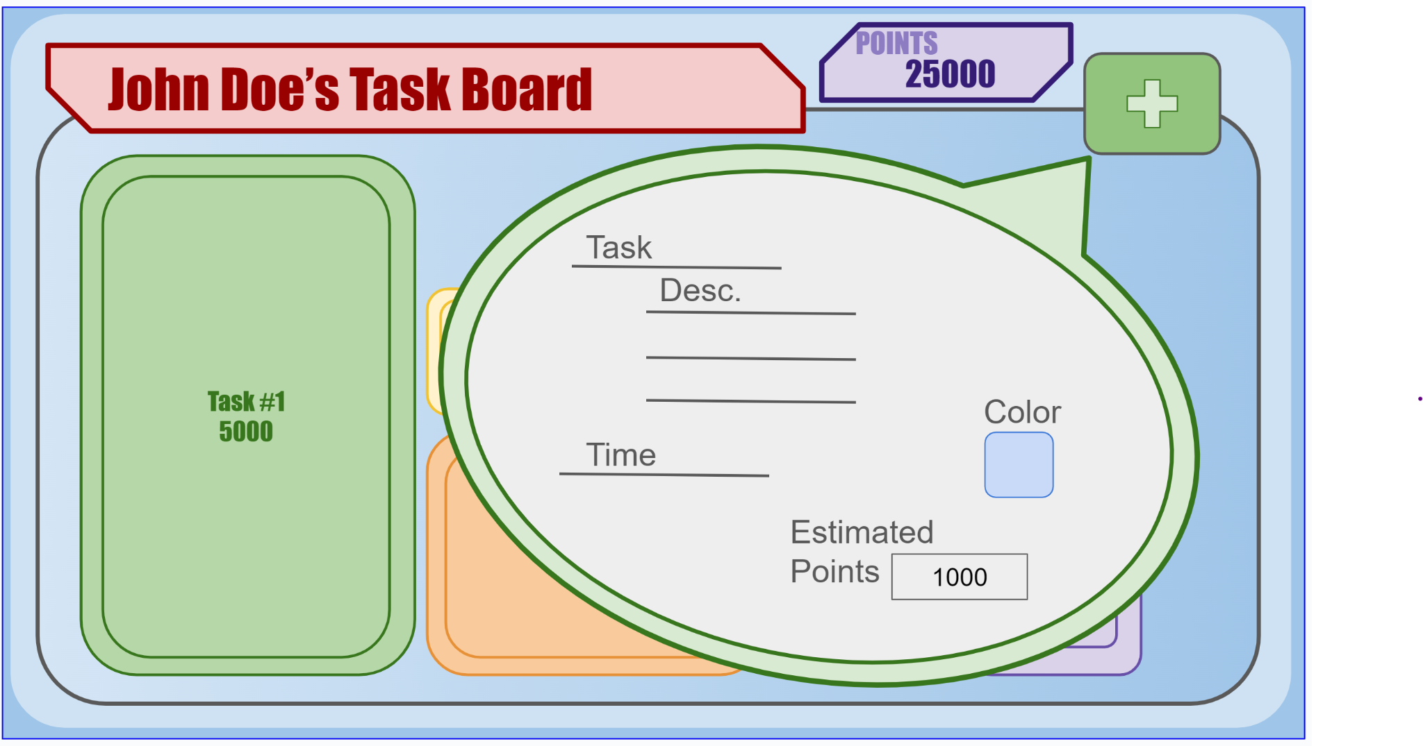

This is what the addition of a new task would look like. It is simple with only a title, an optional description, and an estimated time to complete. Users can choose the color of the bubble, but it will be a random color by default. The points are calculated independently and automatically.

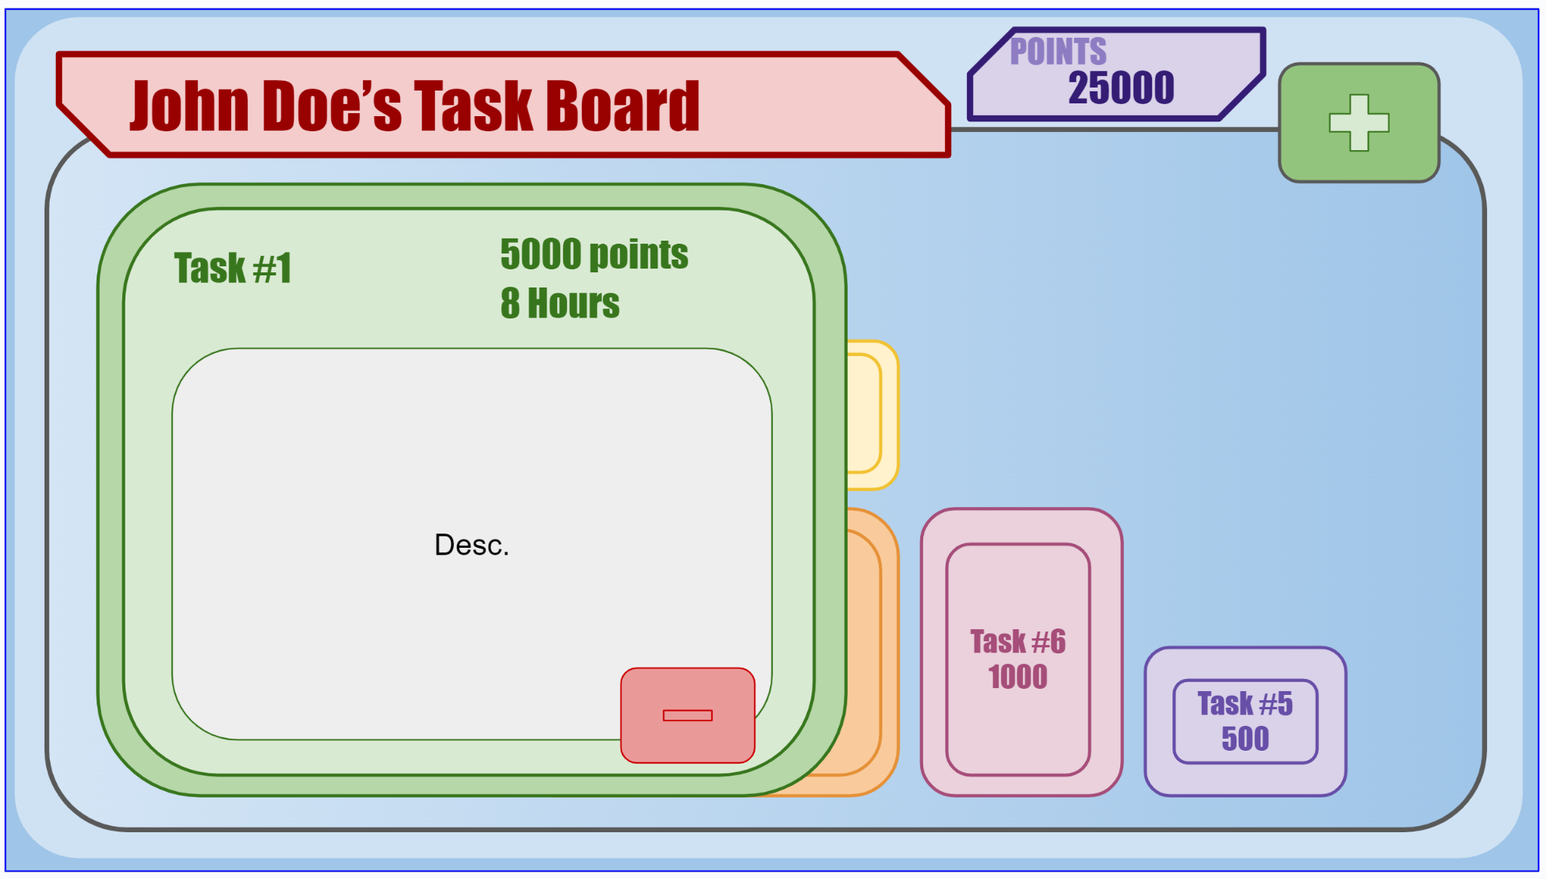

This is what it looks like when a task is highlighted. Notably, the details of the tasks are shown; additionally, a delete button is now an option within the task if the task needs to be deleted.

**Process Deliverable**

We are using the prototyping process. Our GitHub repository, <https://github.com/Ijahmin/cuddly-adventure>, contains our current prototype.